Signs With Smart Connectivity For Better Road Safety

**TEAM:** Deepika.J (19BCS017) , Sulana S Chandarshekar(19BCS019) , Varshini.S (19BCS049) , Kavyaa (19BCS050).

**FACULTY MENTOR :** Yamunathangam D

**PROJECT WORK FLOW**

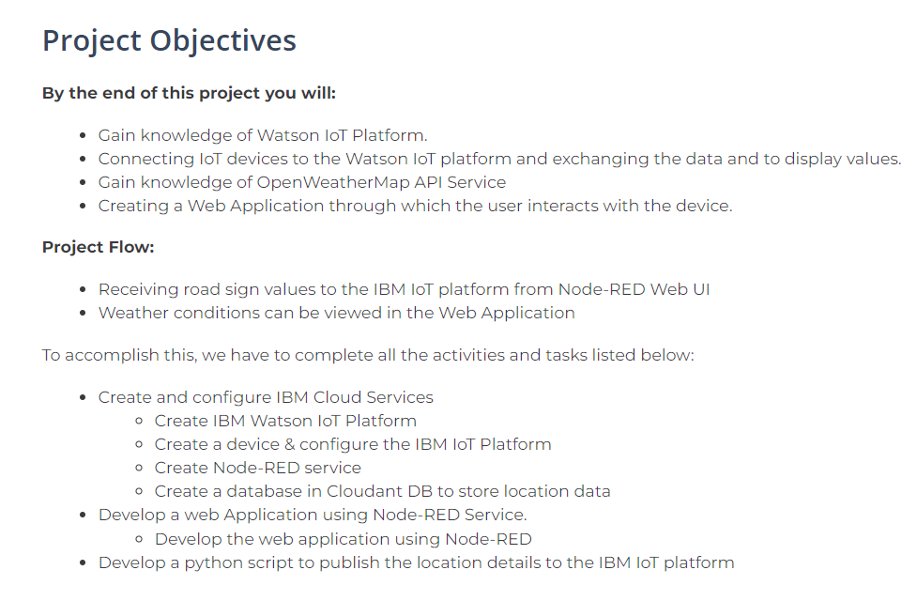

**EMPATHY MAP:**

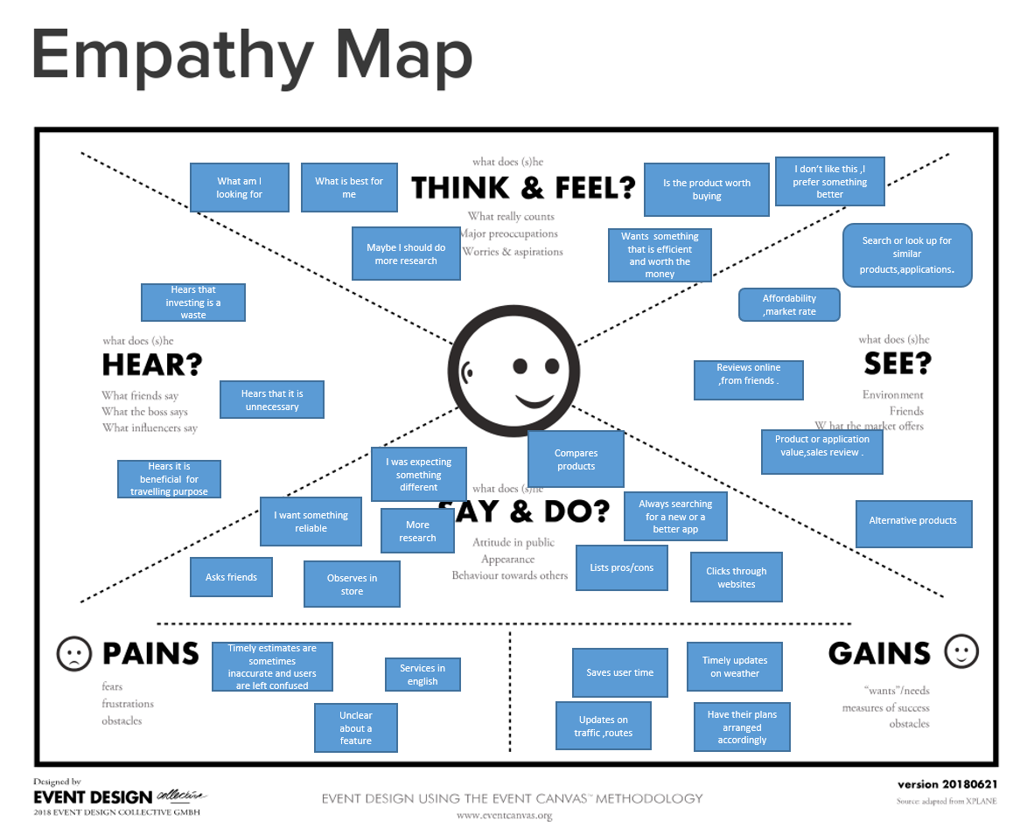

**LITERATURE SURVEY**

a) **Digital Notice Board Based on IOT**

This project presents a digital notice board using IoT module. The idea behind this project is to

provide its users with a simple, fast and reliable way to put up important notices in an LED where the user can send a message to be displayed in the LED. The message can be sent through an android application designed in this project, through the IoT module. So, notices can be put up in an LED display from any location in the world. It uses a microcontroller for system control, IoT based

technology for communication and sends the message through the android application. The project consists of Arduino UNO board, IoT module, an LED, and an android application for user interface with the hardware. This device can be used anywhere irrespective of the place of deployment provided mobile network connectivity is available. This is a project that displays messages that the user desires, on an LED Display Matrix. The Display consists of 256 LED lights, sequentially arranged in 8 rows and 32 columns (8*32). Apart from the display, the project consists of a Node MCU controller which helps the system to connect to the Wi-Fi. This system makes use of Google Assistant to accept speech inputs from user, through user’s Android smartphone. User needs to login into their Google account. A USB cable acts as the power cable for the system. The speech input is converted into a text display in an alphanumeric format which is predefined. The displayed message will either scroll or remain static, based on the size of display and length of message. This project can widely use in offices, schools, educational institutions as well as government and corporate offices to display important notices and messages. This can prove to help users save a lot of time as against the use of traditional pin and paper notice display.

b) **Internet of Things Based Notifications Using Smart Notice Board**

Conventional Notice Board employs manual display and monitoring with papers and ledgers. The Target users are unaware of information displayed on the notice board. The objective of the project is to display the message on the notice board from anywhere and anytime, that even provides broadcast alerts to the target users. The system was designed and developed using the Internet of Things. Arduino board integrates the display unit, Mobile App and SMS Agent through Internet. The message to be displayed on the notice board is sent throu gh a mobile app to the board with Arduino. As soon as the message is displayed, SMS alert is sent to the target users. A system of efficient Notice Board display controlled through the Internet is accomplished and presented in this paper.

c) **An IoT based Smart Monitoring System for Vehicles**

There is increased adoption of penalty and fine for traffic rule violators in the public sector but there is a tendency for people to evade from those imposed fines and restrictions for their own safety. Our system will completely monitor all the traffic violations namely over speeding, rash driving, drunken driving, driving without a seat belt, and so on right from the starting of the car. There is an increasing demand to develop a system to check passengers without coming out of the vehicle. A new system for the police force to check the vehicle's details with a smart device placed in the vehicle. The device is equipped with speed monitoring, Alcohol detection, Seat belt checking, etc. If any violation is detected the controller sends an emergency data to the cloud, thus the vehicle is in continuous monitoring mode, and RTO will get updates about the vehicles which are violating rules. Alcoholic breath sensor will continuously monitor the driver's breath, speed sensor will be connected with the speedometer and checks for over speeding, Seat belt sensor will warn the driver if he/she is not using the seat belt, vehicle details including license, pollution details, insurance, etc. will be uploaded to the server or cloud. If any of the above things are violated, automatically defaulter will be imposed fines and the details will be sent to the Motor vehicle department.

d)**Congestion Adaptive Traffic Light Control and Notification Architecture Using Google Maps APIs :**

Controlling of traffic signals optimally helps in avoiding traffic jams as vehicle volume density changes on temporally short and spatially small scales. Nowadays, due to embedded system development with the rising standards of computational technology, condense electronics boards as well as software packages, system can be developed for controlling cycle time in real time. At present, the traffic control systems in India lack intelligence and act as an open-loop control system, with no feedback or sensing network, due to the high costs involved. This paper aims to improve the traffic control system by integrating different technologies to provide intelligent feedback to the existing network with congestion status adapting to the changing traffic density patterns. The system presented in this paper aims to sense real-time traffic congestion around the traffic light using Google API crowdsource data and hence avoids infrastructure cost of sensors. Subsequently, it manipulates the signal timing by triggering and conveying information to the timer control system. Generic information processing and communication hardware system designed in this paper has been tested and found to be functional for a pilot run in real time. Both simulation and hardware trials show the transmission of required information with an average time delay of 1.2 seconds that is comparatively very small considering cycle time.

Mishra, Sumit Kumar, Devanjan Bhattacharya and Ankit K. Gupta. “Congestion Adaptive Traffic Light Control and Notification Architecture Using Google Maps APIs.” Data 3 (2018): 67.

e) **An IoT based Weather Information Prototype Using WeMos :**

The Internet of Things (IOT) describes the interconnection of devices and people through the traditional internet and social networks for various day-to-day applications like weather monitoring, healthcare systems, smart cities, irrigation field, and smart lifestyle. IOT is the new revolution of today’s internet world which monitors live streaming of the entire world’s status like temperature, humidity, thunderstorm, earthquake, floods etc. that can stagger an alarm to human life. This paper proposes a low-cost weather monitoring system which retrieves the weather condition of any location from the cloud database management system and shows the output on an OLED display. The proposed system uses an ESP8266-EX microcontroller based Wemos D1 board and it is implemented on Arduino platform which is used to retrieve the data from the cloud. The main objective of this paper is to view weather conditions of any location and allows to access the current data of any station.

R. K. Kodali and A. Sahu, "An IoT based weather information prototype using WeMos," 2016 2nd International Conference on Contemporary Computing and Informatics (IC3I), 2016, pp. 612-616, doi: 10.1109/IC3I.2016.7918036.

f) **IOT Based Weather Monitoring and Reporting System Project**

The IOT based Weather Monitoring and Reporting System project is used to get Live reporting of weather conditions. It will Monitor temperature, humidity, moisture and rain level. Suppose Scientists/nature analysts want to monitor changes in a particular environment like volcano or a rain-forest. And these people are from different places in the world. In this case, SMS based weather

monitoring system has some limitations. Since it sends SMS to few numbers. And time for sending SMS increases as the number of mobile numbers increases. In order to know the information about weather of a perticular place then they have to visit that particular sites. Where everyone can see it.

Anita M. Bhagat ,Ashwini G. Thakare ,Kajal A. Molke , Neha S. Muneshwar ,Prof. V. Choudhary IOT Based Weather Monitoring and Reporting System ,2019 .

g) **Incorporating Weather Updates for Public Transportation Users of Recommendation Systems:**

This work presents a system for augmenting the functionality of Yelp-like recommendation sites by enabling users to search for places bounded by travel-time when using public transportation, and modifying recommendations based on updated weather conditions. Using public transport, although is cheaper and efficient, entails that only fixed places of boarding/exiting may be used which, in turn, implies walking to (from) a particular location from (to) a given station. Given the impact of the weather on the mood and activities, preferences for a certain type of services may need to be dynamically adjusted based on the current weather or the near-future forecast, modulo travel-routes

to preferred locations. In this work, we develop a model to predict a user’s preferred mode of transport (car, or public transit) from their old check-ins and incorporate the weather context into

the recommendation process. We use event-based modeling to control the extent of walking depending on user-defined tolerance information and live weather conditions. We implemented a web application (both desktop and mobile platforms), utilizing existing tools such as Google Maps Direction API and OpenWeatherMap API for retrieving real-time information.

M. M. -u. Hussain, B. Avci, G. Trajcevski and P. Scheuermann, "Incorporating Weather Updates for Public Transportation Users of Recommendation Systems," 2016 17th IEEE International Conference on Mobile Data Management (MDM), 2016, pp. 333-336, doi: 10.1109/MDM.2016.57.

h) **System Natural Data is now becoming more valuable in a day to get real-time data for**

**natural data:**

Physical monitoring of the environment allows for the identification of areas suitable for agriculture, industry, and other purposes. In this article, the Arduino-UNO microcontroller-based board is used for the data acquisition strategy and the use of analog and digital sensors. Temperature, humidity, light intensity and gas concentrations can be monitored in real-time [4] [9-12] [13-16].

i) **The impact of daily weather on daily travel trips :**

It is of increasing social interest - climate change and increasing scarcity, understanding the climatic implications of travel behavior, especially walking and biking. Recently, various courses are travel, health, and biometeorology.